Name: Prakhar Sharma
Candidate Registration Number: 1000260
CRS Name: Artificial Intelligence
Course: Capstone Project Y2
School: Ryan Global School, Kharghar
GitHub Link: https://github.com/prakharsharma-cpu/Capstone-Project-finals.-Cultural-AI
Google AI Studio App Link: https://ai.studio/apps/de13602c-2c70-435d-a4ed-5b4679976c87?fullscreenApplet=true

AI Cultural Tourism Insights & Engagement Platform

Product Requirements Document (PRD)

Author: Prakhar Sharma
Project Duration: 10 Weeks

1. Purpose

The purpose of this project is to develop an AI-powered Cultural Tourism Insights & Engagement Platform that helps travelers discover cultural destinations based on their interests and travel goals.

Traditional travel platforms typically provide generic recommendations based on popularity rather than personal cultural interests. Many travelers want to explore experiences such as:

Historical monuments

Cultural festivals

Museums and art galleries

Heritage sites

Local traditions

However, finding relevant cultural destinations requires extensive research across multiple platforms.

This project uses Artificial Intelligence and Generative AI to analyze user preferences and generate personalized cultural travel recommendations and itineraries.

The platform will leverage Google AI Studio and Gemini AI to process user inputs and generate intelligent travel insights.

2. Objectives

The main objectives of the project are:

Build an AI-powered recommendation system for cultural tourism.

Generate personalized cultural travel itineraries using Generative AI.

Create an interactive platform for exploring cultural destinations.

Provide AI-generated cultural insights for travelers.

Demonstrate the use of modern AI tools in tourism planning.

3. Scope

The project focuses on building a prototype AI system capable of recommending cultural tourism destinations and generating travel plans.

Modules included in the system

User Preference Module

Collects traveler information such as:

Cultural interests

Travel goals

Budget

Travel duration

Cultural Recommendation Engine

Uses AI to match user preferences with cultural destinations.

AI Itinerary Generator

Generates personalized travel schedules using AI.

Cultural Insights Generator

Provides descriptions and insights about cultural destinations.

4. Stakeholders

Travelers

Travelers can discover cultural destinations tailored to their interests.

Tourism Organizations

Tourism boards can promote cultural heritage locations.

Travel Agencies

Travel companies can use AI insights to design travel packages.

5. Deliverables

The project will produce the following deliverables:

AI cultural recommendation engine

AI-generated travel itinerary system

Cultural insights generator

Interactive prototype interface

Final project documentation

6. Tools and Technologies

Only the following tools will be used.
Tool | Purpose
Google AI Studio | Cloud-based development environment for building and testing AI applications with scalable infrastructure
Gemini AI | Multi-modal AI model that processes text, images, and contextual data to generate personalized cultural recommendations based on user preferences and travel goals

7. AI Workflow

The workflow explains how the system generates recommendations.

Step 1: User Interaction

The user opens the platform and enters:

interests

travel goals

travel duration

budget

Step 2: AI Processing

The platform sends the user data to Google AI Studio, where Gemini AI processes the request.

Gemini AI analyzes:

cultural interests

destination characteristics

travel context

Step 3: Recommendation Generation

Gemini AI identifies cultural destinations that match user interests.

Step 4: Itinerary Creation

Gemini AI generates a personalized travel schedule.

Step 5: Results Display

The platform displays:

destination recommendations

cultural insights

travel itinerary

8. Weekly Development Plan

Week 1 – Project Research

Define the problem statement and research cultural tourism.

Week 2 – Data Collection

Collect datasets for cultural destinations and tourism information.

Week 3 – Data Preparation

Clean and organize tourism data for AI processing.

Week 4 – AI Model Design

Design the recommendation logic and AI prompts.

Week 5 – Gemini AI Integration

Connect the platform with Gemini AI using Google AI Studio.

Week 6 – Personalization Module

Develop the user preference input system.

Week 7 – Cultural Insights Generator

Enable Gemini AI to generate cultural descriptions.

Week 8 – Interface Development

Develop the platform interface and login page.

Week 9 – Testing and Optimization

Improve recommendation accuracy and AI responses.

Week 10 – Final Integration

Prepare final system demonstration and project presentation.

9. Risk Management

AI Recommendation Accuracy

AI may generate irrelevant recommendations.

Mitigation: Improve prompts and refine user inputs.

Data Availability

Limited cultural tourism data may affect results.

Mitigation: Expand datasets using open tourism resources.

External AI Dependency

Reliance on Gemini AI may cause interruptions.

Mitigation: Store generated responses and optimize prompts.

10. Evaluation Criteria

The project will be evaluated based on:

Innovation

Use of AI and Generative AI in tourism planning.

Technical Implementation

Successful use of Gemini AI with Google AI Studio.

Usability

Ease of use and clarity of the interface.

Cultural Impact

Ability to promote cultural tourism experiences.

11. Conclusion

The AI Cultural Tourism Insights & Engagement Platform demonstrates how artificial intelligence can improve tourism planning by delivering personalized cultural experiences.

By leveraging Google AI Studio and Gemini AI, the platform can analyze user preferences and generate intelligent travel recommendations.

This project shows how AI can transform tourism by enabling travelers to discover meaningful cultural destinations and engage more deeply with global heritage.

12. Screenshots
- Login Page:

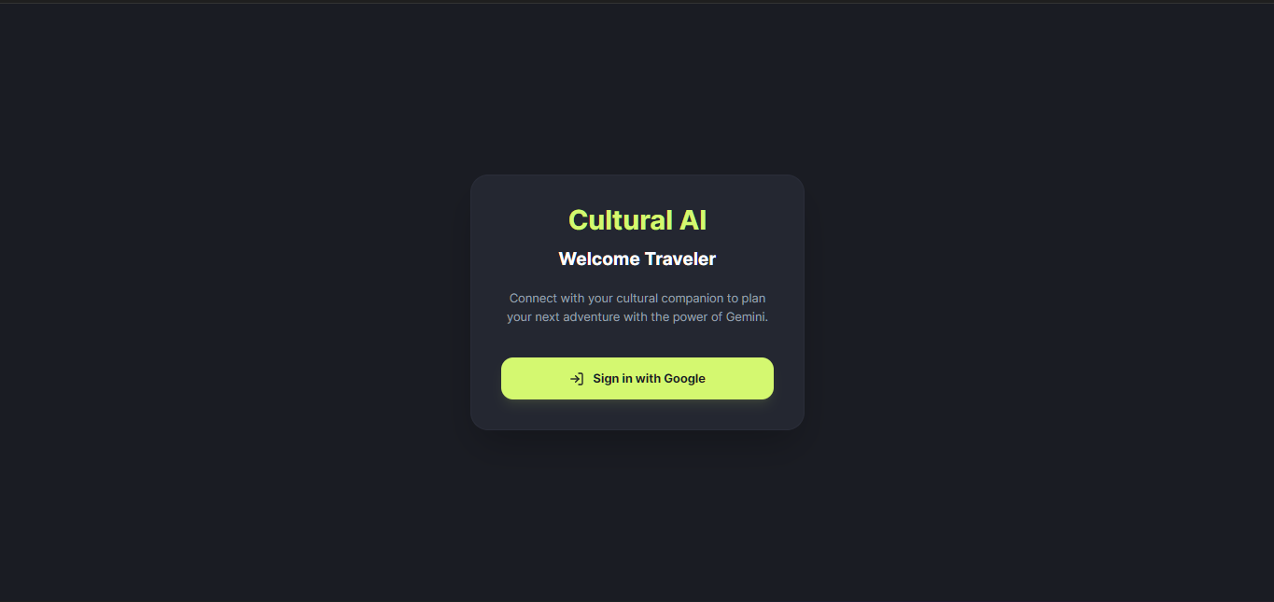

- Home Page:

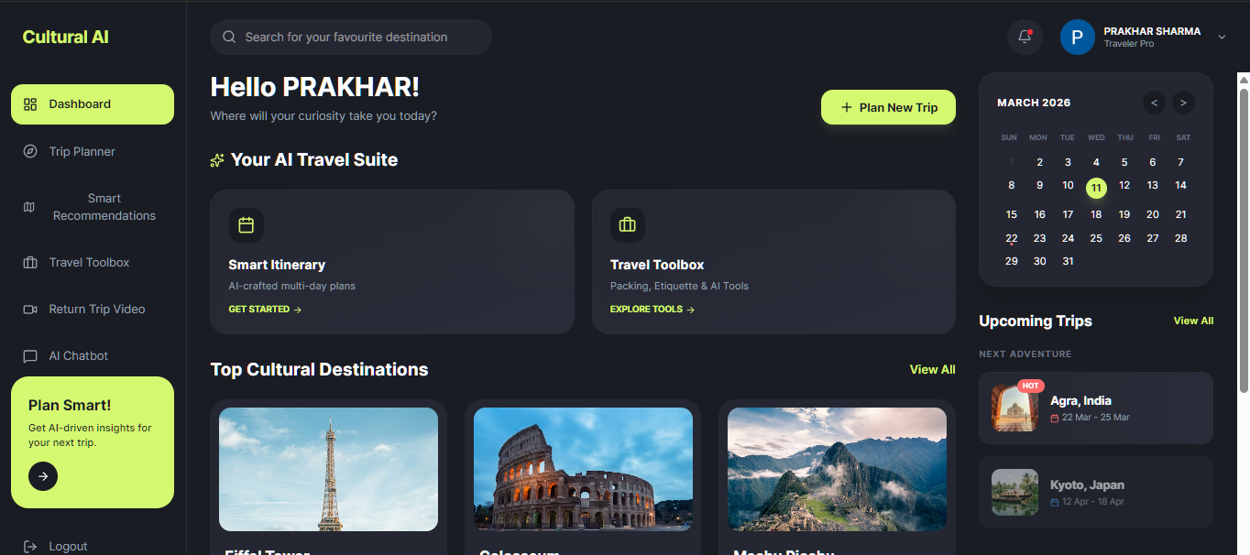

- Trip Planner:

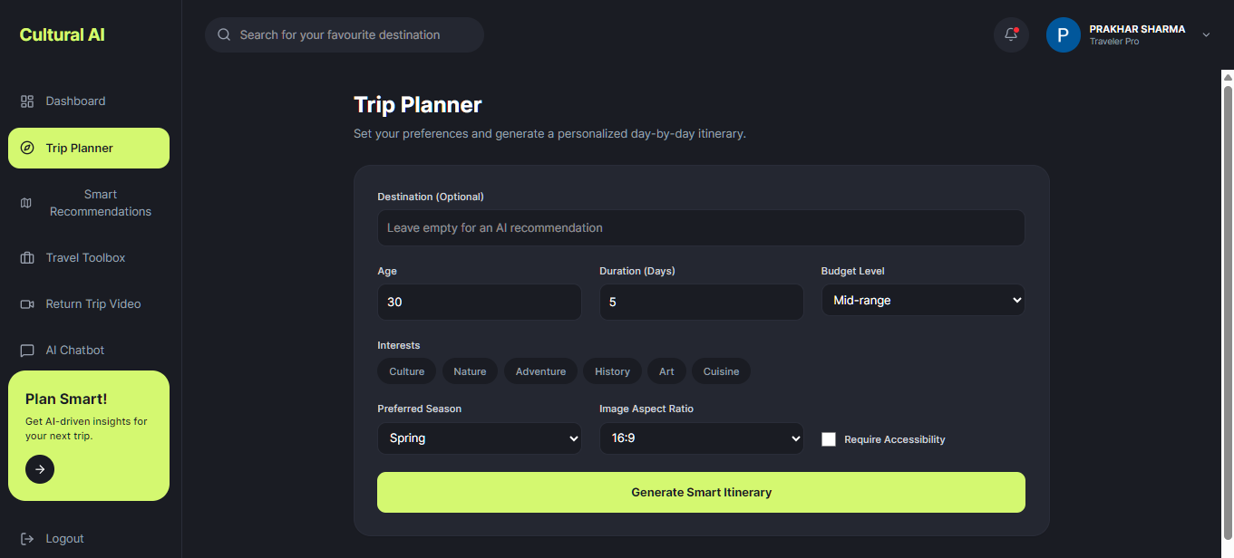

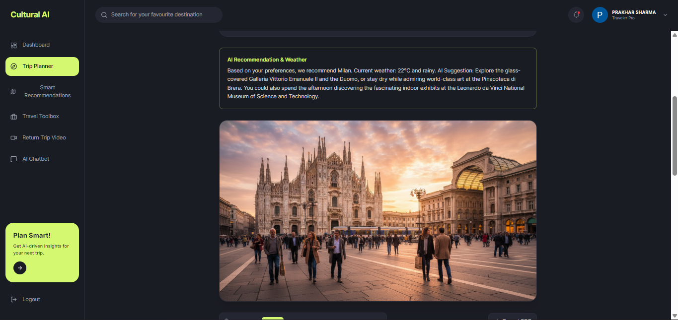

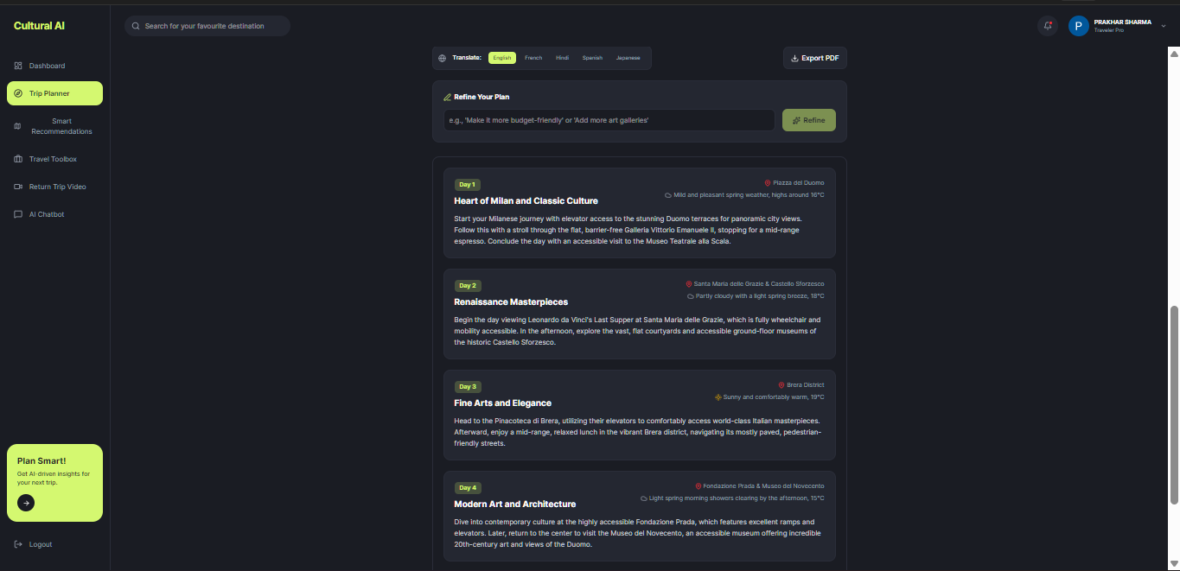

- Smart Recommendations:

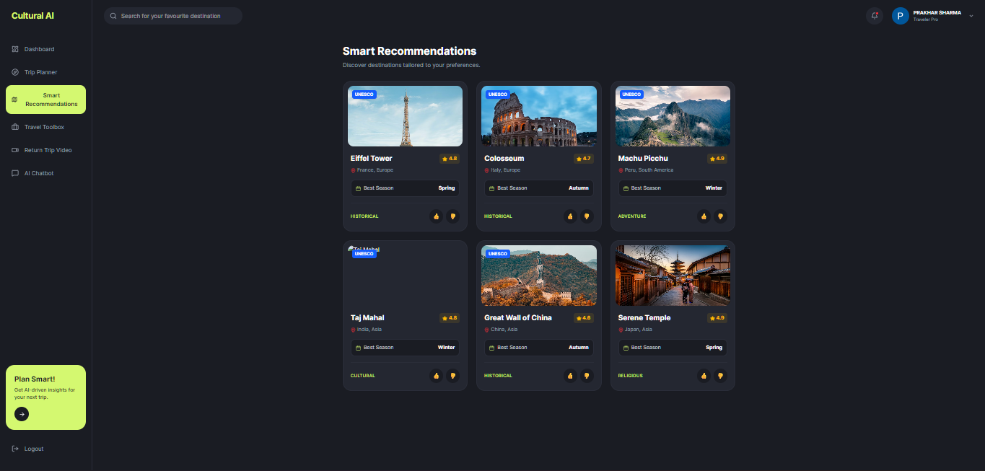

- Travel Toolbox:

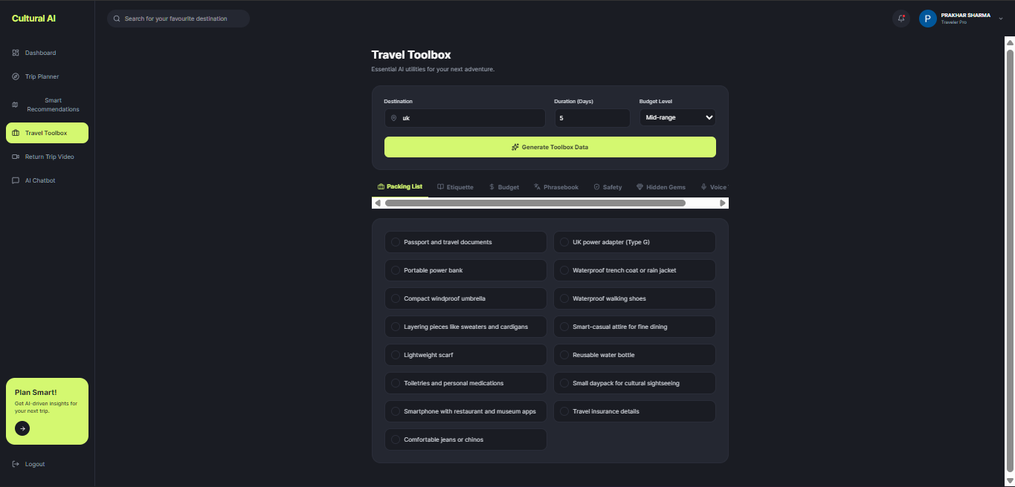

- Return Trip Video:

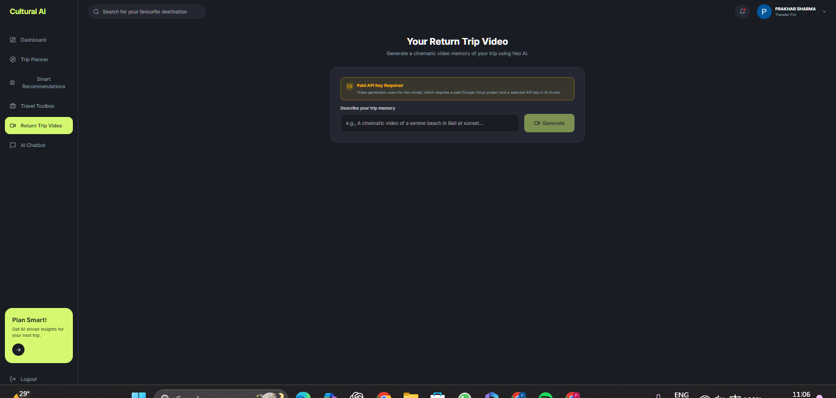

- AI Chatbot:

